

**R & D Project Report**

**Academic Year- 2022-23**

On

**Identification of diseases in the crops using Digital Image Processing**

Submitted by

1. Om Gholap BT20HCS007 BTech DS
2. Vishishta Ranjan BT20HCS019 BTech DS
3. Kritik Prabhakar BT20HCS353 BTech AI

Dr. Vikas Upadhyaya



==========================================================================================================================================

**CERTIFICATE BY SUPERVISOR(S)**

This is to certify that the present R&D project entitled Identification of diseases in the crops using Digital Image Processing being submitted to NIIT University, Neemrana, in partial fulfilment of the requirements for the award of the Degree of Bachelor of Technology, in the area of BT/CSE/ECE/GIS, embodies faithful record of original research carried out by Om Gholap, Vishishta Ranjan, Kritik Prabhakar. They have worked under my guidance and supervision and that this work has not been submitted, in part or full, for any other degree or diploma of NIIT or any other University.

Place:

Name of the Supervisor(s) with signature:

Dr. Vikas Upadhyaya

Date:



=======================================================================================================================================

**DECLARATION BY STUDENT(S)**

I/We hereby declare that the project report entitled Identification of diseases in the crops using Digital Image Processing which is being submitted for the partial fulfilment of the Degree of Bachelor of Technology, at NIIT University, Neemrana, is an authentic record of my/our original work under the guidance of Dr.Vikas Upadhyaya. Due acknowledgements have been given in the project report to all other related work used. This has previously not formed the basis for the award of any degree, diploma, associate/fellowship or any other similar title or recognition in NIIT University or elsewhere.

Place:

Date:

**Om Gholap BT20HCS007 BtechDS Signature**

**Vishishta Ranjan BT20HCS019 BtechDS Signature**

**Kritik Prabhakar BT20HCS353 BtechCSE Signature**

# **Acknowledgement:**

I want to express my sincere gratitude to everyone who contributed significantly to the success of our initiative. First and foremost, I would like to express my sincere gratitude to Dr. Vikas Upadhyaya, my mentor, and supervisor, for his essential advice, vast expertise, and steadfast support during this project. The direction and caliber of this work have been significantly influenced by their astute suggestions and helpful critiques.

I am incredibly appreciative that Dr. Ratna Sanyal gave me the chance to take part in this educationally rewarding event. I am very grateful for her ongoing aid and wise counsel, both of which have been really helpful.

Additionally, I want to thank the academic and research institutions that gave me access to the tools, facilities, and literature I needed. The range and depth of this research have been greatly increased by their contributions.

I sincerely appreciate the help and cooperation from my classmates and coworkers. Their openness to contributing their thoughts and expertise has been crucial in enhancing this endeavor and broadening my comprehension of the subject.

My team’s consistent support, compassion, and tolerance as this project developed has been much appreciated. They have consistently praised me and had faith in my competence, which has served as a steady source of inspiration.

Finally, I would want to express my sincere gratitude to everyone who took part in this study. Their significant contributions and willingness to lend their time and knowledge were crucial to its success.

This initiative would not have been achieved without their assistance and joint participation. I sincerely appreciate their contributions because they had a big influence on how this study turned out.

# Content Page:

**Content Page:** **3**

**Abstract** **4**

**1) Introduction** **5**

**2) Related Works:** **6**

**3) Proposed methodology:** **9**

3.1) Overview: 9

3.1.1) DataSet Collection: 9

3.1.2.) Data Cleaning: 9

3.1.3.) Data Processing: 10

3.1.4.) Model Building: 10

3.1.5.) Conversion to tf Lite Model: 10

3.1.6.) Deployment on Google Cloud: 10

3.1.7. ) Mobile App Development: 10

3.2) Workflow 11

3.2.1) Data Collection and Preparation: 11

3.2.2) Model Building: 11

3.2.3) Model Evaluation and Optimization: 12

3.2.4) Backend Server: 12

3.2.5) Frontend Development: 12

3.2.6) Deployment to Google Cloud Platform (GCP): 13

3.3) Technology 13

3.3.1). VS Code: 13

3..3.2). TensorFlow: 14

3.3.3.) Python: 14

3.3.4.) CNN (Convolutional Neural Network): 14

3.3.5.) NumPy: 14

3.3.6.) React.js: 14

3.3.7.) React Native: 15

3.3.8.) FastAPI: 15

**4) Results and Analysis:** **16**

**5)** **Conclusions and Future Scope.** **17**

**6)** **References** **18**

# **Abstract**

Potato farmers worldwide suffer significant economic losses due to diseases affecting their crops, with Early Blight and Late Blight being two prevalent and devastating diseases. Timely detection and effective treatment of these diseases are crucial for minimizing losses and ensuring sustainable potato production. This research paper focuses on the development of a Leave Disease Detection system using Digital Image Processing (DIP) and Deep Learning techniques to detect Early Blight and Late Blight in potato plants. The proposed system utilizes digital images of infected leaves and employs advanced pattern recognition capabilities of Deep Learning algorithms to accurately classify the presence of these diseases. By integrating DIP and Deep Learning, the system aims to provide farmers with an automated and reliable tool for early disease detection, enabling prompt intervention and mitigating crop losses. The research highlights the potential of this approach to empower farmers, reduce economic losses, promote sustainable agricultural practices, and ensure global food security.

**Keywords:**

Leave Disease Detection, Early Blight, Late Blight, Digital Image Processing, Deep Learning, Disease Identification.

# **1) Introduction**

Potatoes are a staple crop, playing a crucial role in global food security and the livelihoods of farmers worldwide. However, potato farmers often encounter significant economic losses due to various diseases that can afflict potato plants. Among these diseases, Early Blight and Late Blight stand out as two common and highly destructive pathogens. Timely detection and appropriate treatment of these diseases can mitigate losses and prevent economic devastation.

A fungus known as Alternaria solani is the source of the illness known as Early Blight., and Late Blight, caused by the microorganism Phytophthora infestans, pose significant threats to potato crops. Early Blight typically manifests as dark lesions on leaves, stems, and fruits, while Late Blight leads to water-soaked lesions that rapidly spread, resulting in the destruction of foliage and tubers. The severity of these diseases necessitates early detection and prompt intervention to prevent their escalation.

Traditional methods of disease detection, relying on visual inspection by farmers, are often limited in accuracy and efficiency. To overcome these limitations, we turn to the powerful combination of Digital Image Processing (DIP) and Deep Learning techniques. DIP enables the analysis and extraction of valuable information from digital images of infected leaves, while Deep Learning algorithms provide advanced pattern recognition capabilities necessary for accurate disease identification.

This research paper aims to explore the integration of DIP and Deep Learning in the detection of Early Blight and Late Blight in potato plants. By utilizing digital images of infected leaves, we seek to develop an automated system capable of accurately identifying and classifying the presence of these diseases. The proposed system will assist farmers in detecting diseases at an early stage, enabling them to implement timely and targeted treatments, thus minimizing crop losses and preserving economic viability.

This study is significant because it has the potential to provide potato producers with a dependable and effective tool for disease identification. By incorporating DIP and Deep Learning, farmers can overcome the limitations of manual inspection, ensuring early identification and appropriate action. This proactive approach will not only reduce economic losses but also contribute to sustainable agricultural practices by minimizing pesticide usage and promoting optimal resource allocation.

# 

# 

# **2) Related Works:**

**1.** In the (Andrew et al., 2022), a technique is presented for detecting leaf dieseases in crops through deep learning techniques. The technique encompasses facts series, preprocessing, augmentation, model architecture design, training, and deployment degrees. The paper additionally identifies numerous gaps within the examination, including barriers which include a small dataset, magnificence imbalance, a loss of interpretability inside the model, and inadequate robustness. To cope with these gaps, recommendations are made to provide additional dataset information, delve deeper into the model structure, explore sensible implications of the studies, and provide a more comprehensive conclusion. Through incorporating these hints, the paper's normal pleasantness and practicality inside the area of agricultural sickness detection may be advanced.

**2.** The research (Kulkarni et al., n.d.), Introduces an technique for plant sickness identity that employs photograph processing and system learning methodologies. The technique encompasses diverse levels, which includes photo preprocessing, feature extraction, class, performance assessment, and sensitivity analysis. however, the paper identifies numerous gaps within the examine, including boundaries in generalization, interpretability, real-time software, and robustness. To address those gaps, We recommend a hard and fast of suggestions. those hints involve increasing the dataset to improve generalization abilities, incorporating explainability methods to decorate interpretability, and thinking about the impact on farmers for actual-time software. with the aid of implementing these tips, the paper targets to decorate the general validity and practicality of the research, allowing higher generalization, interpretability, real-time usage, and robustness in plant disease detection.

**3.** The research (Maniyath et al., 2018) ,introduces a methodology for detecting plant diseases through machine learning techniques. The approach involves extracting features using Hu Moments, Harlick texture, and Color Histogram, followed by classification using the Random Forest algorithm. The paper identifies two gaps: the need for plain background images for texture detection and low accuracy resulting from a small dataset. To address these gaps, we propose focusing on classifying spots on the leaves and utilizing a larger dataset to enhance accuracy. By implementing these suggestions, the aim is to enhance the performance and dependability of the machine learning-based plant disease detection system.

**4.** The research (Ishak et al., 2015), gives a technique for classifying leaf disease through the utilization of artificial neural networks. The technique encompasses numerous degrees, which includes photo capture, evaluation adjustment, virtual image processing operations, image segmentation, function extraction, records analysis, and classification. We indentify two gaps in the paper methodology. First off, the employment of Multi-Layer Perceptron (MLP) and Radial Basis Function (RBF) for image classification is novel.Secondly, they deal with the capability difficulty of overfitting because of high accuracy finished on a smaller dataset. To triumph over these gaps, we suggest employing Convolutional Neural Networks (CNNs) for the image classification, as they are especially designed for this reason. Moreover, it is recommended to use a larger dataset to enhance accuracy and mitigate the risk of overfitting.

**5.** The research paper (Mohanty et al., 2016) introduces a technique for plant disease detection using deep learning and image analysis. The proposed method involves time series data preprocessing, model training, evaluation, and deployment. However, we identify several limitations. Firstly, the performance of the models is hindered by the use of a limited dataset for training. Secondly, the hardware requirements for implementing deep learning algorithms may pose accessibility challenges. Lastly, the trained models exhibit limited applicability to specific regions or factors. To address these gaps, the authors suggest collecting large and diverse datasets encompassing various factors, utilizing cloud computing services to overcome hardware limitations, and acquiring data from different regions to enhance model generalization. These suggestions seek to strengthen the approach, boost model functionality, and broaden it.

**3) Proposed methodology:**

## 3.1) Overview:

Through the use of Digital image Processing (DIP) and Deep Learning, the objective of Leave Disease Detection will be achieved, we outline a unique and innovative methodology that combines various steps to achieve accurate and efficient disease detection in plant leaves.

### 3.1.1) Dataset Collection:

We obtain the Plant Village Dataset, a comprehensive collection of annotated plant images containing instances of Early Blight and Late Blight, along with healthy leaf samples. This dataset serves as the foundation for training and evaluating our models.

### 3.1.2.) Data Cleaning:

We perform data cleaning processes to ensure the dataset's quality and consistency. This step involves removing duplicate or corrupted images, handling missing or erroneous annotations, and ensuring uniform formatting.

### 3.1.3.) Data Processing:

Leveraging the TensorFlow (tf) dataset framework, we preprocess the dataset by normalizing the image data and splitting it into training and testing subsets. Additionally,We use data augmentation methods to increase the diversity and robustness of the training data, such as random translations, flips, and rotations.

### 3.1.4.) Model Building:

We design a Convolutional Neural Network (CNN) architecture specifically for identifying leaf diseases. The preprocessed dataset is used to train the CNN model, which discovers the distinguishing traits and patterns linked to Early Blight, Late Blight, and healthy leaves.Training is performed using state-of-the-art optimization algorithms and loss functions.

### 3.1.5.) Conversion to tf Lite Model:

To facilitate easy deployment and usage on mobile devices,We create a TensorFlow Lite (tf Lite) model using the trained CNN model.This conversion process involves applying quantization techniques to reduce the model's size and memory footprint while maintaining a satisfactory level of accuracy. By utilizing tf Lite models, we enable seamless integration into mobile applications, providing a user-friendly experience for farmers.

### 3.1.6.) Deployment on Google Cloud:

The converted tf Lite model is deployed on the Google Cloud platform, ensuring scalability, accessibility, and efficient processing of disease detection requests. The cloud deployment enables real-time disease diagnosis, allowing farmers to receive immediate feedback and actionable insights.

### 

### 3.1.7.) Mobile App Development:

We develop a mobile application using React Native and ReactJS frameworks. This intuitive and user-friendly app allows farmers to capture images of plant leaves, which are then processed using the deployed tf Lite model for disease detection. The app displays the diagnosis results, highlighting the presence and severity of Early Blight or Late Blight, assisting farmers in making informed decisions for disease management.

Through this proposed methodology, we aim to provide an effective and accessible solution for Leave Disease Detection. By leveraging the power of DIP, Deep Learning, and cloud-based deployment, we enable farmers to detect and address diseases promptly, minimizing crop losses and promoting sustainable agricultural practices.

## 

## 3.2) Workflow

| **Model Building** | TensorFlow | Convolutional Neural Network | Data Augmentation | tf Dataset |
| --- | --- | --- | --- | --- |
| **Backend Server** | tf Serving | Fast API |  |  |
| **Model Optimization** | Quantization | TensorFlow Lite |  |  |
| **Frontend & Deployment** | React JS | React Native | Deployment to GCP |  |

**Table 1: Workflow of the Detection App**

## 

### 3.2.1) Data Collection and Preparation:

* Collect a diverse dataset of digital images of healthy and diseased potato leaves, including samples of Early Blight and Late Blight.
* Annotate the dataset to label each image with the corresponding disease type (healthy, Early Blight, or Late Blight).
* Create training, validation, and testing sets from the dataset.

## 

### 3.2.2) Model Building:

* Construct a Convolutional Neural Network (CNN) model using TensorFlow, a well-liked deep learning framework.
* Convolutional, pooling and fully linked layers are suitable layer types to include in the CNN design.
* Learn the features that distinguish healthy leaves from diseased ones by training the model using the training dataset and optimizing the model's parameters.
* To improve the model's resilience and generalizability, use data augmentation techniques such as random rotations, flips, and zooms.
* To quickly load and preprocess the dataset while performing transformations and batching, use the TensorFlow Dataset (tf. data) API.

### 3.2.3) Model Evaluation and Optimization:

* Utilising the validation dataset, assess the performance of the trained model by looking at indicators like accuracy, precision, recall, and F1 score.
* Adjust the model's hyperparameters and architecture as needed, taking performance evaluation findings into account.
* Use model optimization methods to accelerate inference by reducing the model's memory footprint, such as quantization.
* To deploy the optimized model on devices with limited resources, convert it to TensorFlow Lite format.

### 3.2.4) Backend Server:

* Implement an API endpoint that accepts image inputs and performs inference using the trained model.
* Integrate TensorFlow Serving, a system for serving TensorFlow models, to facilitate efficient model deployment and inference.

### 3.2.5) Frontend Development:

* Design an intuitive user interface for uploading potato leaf images and displaying the disease detection results.
* Implement image preprocessing on the front end, such as resizing and normalization, before sending images to the backend server for inference.
* Develop a responsive and user-friendly interface that provides visual feedback on disease detection results and confidence scores.

### 3.2.6) Deployment to Google Cloud Platform (GCP):

* Deploy the backend server, built with FastAPI and TensorFlow Serving, to a cloud-based environment on Google Cloud Platform (GCP).
* Set up appropriate infrastructure, such as a virtual machine instance or Kubernetes cluster, to host the server.
* Deploy the frontend application to GCP, configuring it to interact with the backend server API.
* Ensure proper security measures, such as authentication and encryption, to protect sensitive data during communication between the frontend and backend.

## 3.3) Technology

### 

### 3.3.1). VS Code:

We have used Visual Studio Code, for writing, editing, and organizing the codebase. Benefit from the extensive library of extensions available in the VS Code marketplace, enhancing productivity and providing support for various programming languages and frameworks.

### 3.3.2). TensorFlow:

Employ TensorFlow, an open-source deep learning framework, for building and training convolutional neural network (CNN) models for potato disease detection. Leverage TensorFlow's extensive set of pre-built functions and tools to facilitate model development, optimization, and evaluation. Utilize TensorFlow's high-level APIs, such as Kera’s, to simplify the process of designing and training deep learning models.

### 3.3.3.) Python:

Utilize the Python programming language as the primary language for implementing the potato disease detection system. Benefit from Python's simplicity and readability, making it easier to write and maintain code for image processing, data manipulation, and model training. Leverage the vast ecosystem of Python libraries and packages, such as NumPy, matplotlib, and scikit-learn, for tasks like image loading, data preprocessing, visualization, and evaluation.

### 3.3.4.) CNN (Convolutional Neural Network):

Use CNN, a kind of deep neural network created especially for image processing tasks, to find potato diseases. Utilize the natural ability of CNNs to pool and convolutional layers to automatically learn and extract pertinent characteristics from input images. Take advantage of CNN's ability to capture spatial dependencies and hierarchical representations, making it suitable for detecting complex patterns and structures in potato leaf images. Leverage techniques such as transfer learning, which utilizes pre-trained CNN models, to accelerate model development and improve performance with limited training data.

### 3.3.5.) NumPy:

Utilize NumPy, a fundamental Python library for numerical computing, to convert potato leaf images into arrays. Leverage NumPy's multidimensional array objects to represent and manipulate the pixel values of the images.

### 3.3.6.) React.js:

For building UI we have used React.js, to develop the frontend application for the potato disease detection system. Benefit from Reacts virtual DOM (Document Object Model) concept, which enables efficient updating and rendering of UI elements, resulting in a responsive and interactive user interface. Utilize Reacts state management capabilities to handle user interactions, manage image uploads, and display disease detection results.

### 3.3.7.) React Native:

It is a framework for building native mobile applications. Benefit from React Native's extensive library of pre-built UI components and APIs, enabling the development of a native-like user experience for mobile users.Leverage React Native's hot-reloading feature, which facilitates rapid development and testing cycles by instantly reflecting code changes on the device without requiring a full rebuild.

### 3.3.8.) FastAPI:

We have used FastAPI as the backend, a high-performance web framework for creating Python APIs.

# **4) Results and Analysis:**

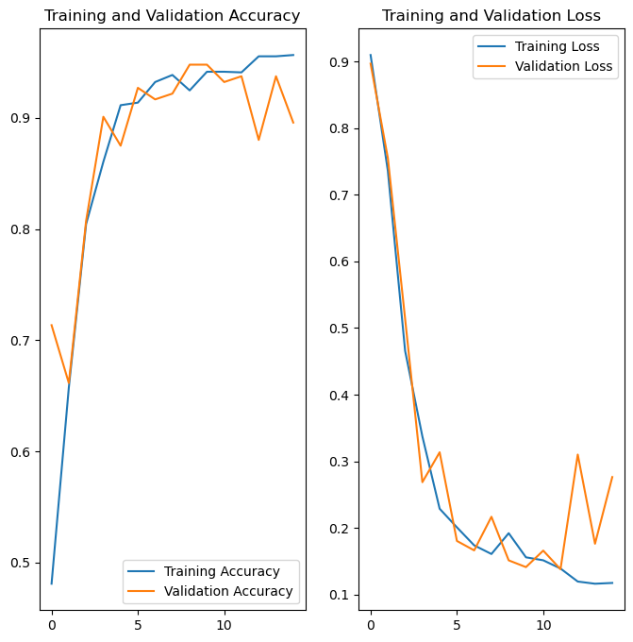

Fig.1 Loss values of First 5 EPOCHS

This graph above shows the loss values and accuracy values exhibit a decreasing trend, indicating that the model is progressively improving its predictions. This implies that our model is learning from the training data and adjusting its parameters to better fit the patterns and relationships present in the data.

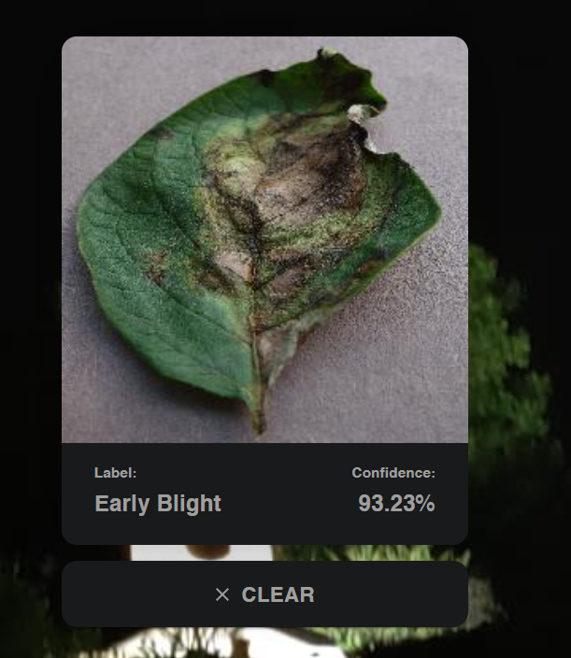

Fig.2 Output of our app, with the disease name and the confidence level.

Our model successfully processed the input image and classified it as having early blight disease with a confidence level of 93.2%. This high confidence level indicates that the model is quite certain about its classification. With such accurate predictions and confidence levels, our model can provide valuable insights for identifying and addressing early blight in potato plants, aiding in timely interventions, and ensuring healthier crop yields.

# 

# **Conclusions and Future Scope.**

The results of our research into the detection of potato diseases using deep learning and digital image processing are encouraging. We have successfully developed an automated system capable of correctly diagnosing and classifying Early Blight and Late Blight illnesses in potato plants by utilising potent tools like TensorFlow, CNNs, and data augmentation. This system empowers farmers with an efficient and reliable tool for timely disease detection, minimizing crop losses and ensuring food security.

However, there are areas for improvement. Firstly, expanding the dataset to include a wider range of potato varieties and disease severities would enhance the system's accuracy. Additionally, exploring advanced Deep Learning techniques, such as ensemble models and attention mechanisms, can capture more intricate patterns and improve disease identification.

Looking to the future, integrating cloud-based solutions like TensorFlow Serving and incorporating IoT and remote sensing technologies for continuous crop monitoring hold promise. Moreover, considering sustainability, incorporating sensor technologies and exploring hybrid mobile frameworks can provide a seamless user experience while minimizing environmental impact.

By addressing these shortcomings and pursuing the outlined scope for improvement, we can advance the field of potato disease detection, foster sustainable agricultural practices, and support farmers in mitigating economic losses worldwide.

# 

# 

# 

# 

# 

# **References**

1. Andrew, J., Eunice, J., Popescu, D. E., Chowdary, M. K., & Hemanth, J. (2022). Deep Learning-Based Leaf Disease Detection in Crops Using Images for Agricultural Applications. *Agronomy*, *12*(10). https://doi.org/10.3390/agronomy12102395
2. Ishak, S., Rahiman, M. H. F., Kanafiah, S. N. A. M., & Saad, H. (2015). Leaf disease classification using artificial neural networks. *Jurnal Teknologi*, *77*(17), 109–114. https://doi.org/10.11113/jt.v77.6463
3. Kulkarni, P., Karwande, A., Kolhe, T., Kamble, S., Joshi, A., & Wyawahare, M. (n.d.). *Plant Disease Detection Using Image Processing and Machine Learning*.
4. Maniyath, S. R., Vinod, P. V., Niveditha, M., Pooja, R., Prasad Bhat, N., Shashank, N., & Hebbar, R. (2018). Plant disease detection using machine learning. *Proceedings - 2018 International Conference on Design Innovations for 3Cs Compute Communicate Control, ICDI3C 2018*, 41–45. https://doi.org/10.1109/ICDI3C.2018.00017
5. Mohanty, S. P., Hughes, D. P., & Salathé, M. (2016). Using deep learning for image-based plant disease detection. *Frontiers in Plant Science*, *7*(September). https://doi.org/10.3389/fpls.2016.01419